Patterns Flowcharts :-

1. Floyd’s Triangle :-

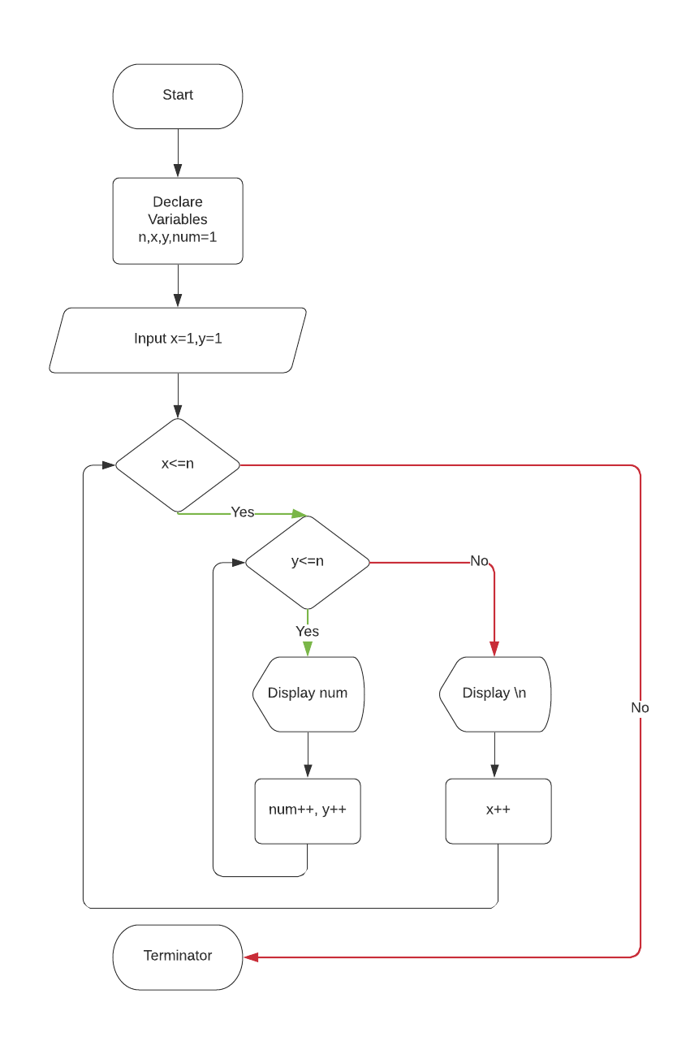1

1

2 3

4 5 6

7 8 9 10

Algorithm :-

Step 1 - start

Step 2 – Declare and initialize required variabes for controlling loop, inputting numbers of rows and printing numbers.

Step -3 Enter the number of rows to be printed.

Step – 4 Print the number in standard format utilizing the application of loop as follows

do for x=1 to n

do for y=1 to n

print number

increase the number ans y by 1

go to step-5

step – 5 print half pyramid of numbers

step – 6 stop

1. Half Pyramid of “\*” :-

Algorithm :-

Step 1- start

Step 2 – Declare and initialize required variables for controlling loop, inputting numbers of rows and printing \*.

Step – 3 Enter the number of rows to be printed.

Step – 4 print the \* and go to step-5

Step – 5 print half pyramid of \*

Step – 6 Stop

\*

\* \*

\* \* \*

\* \* \* \*

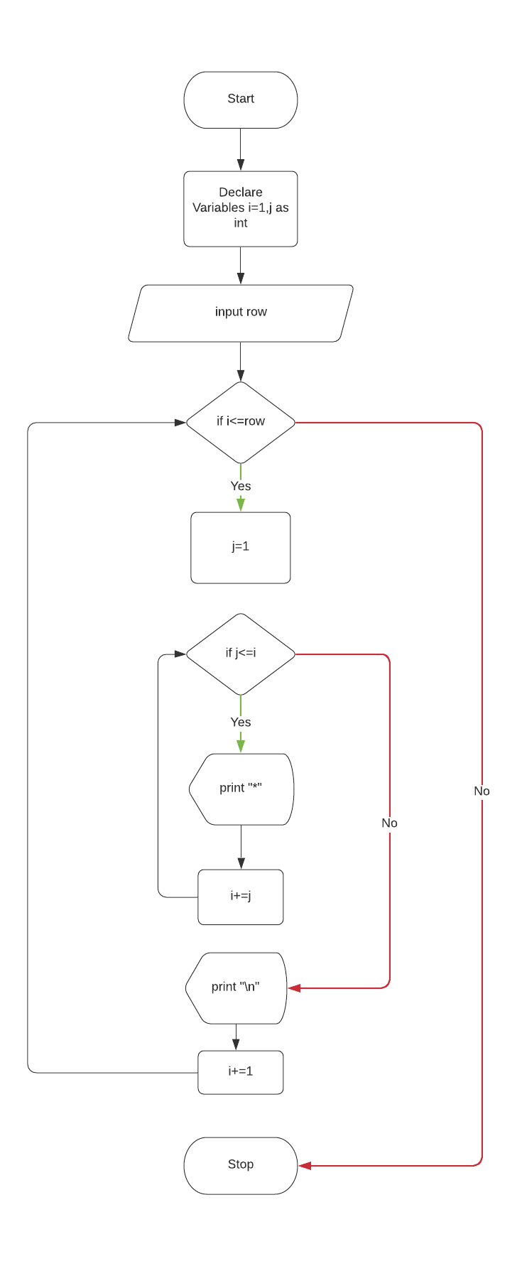

1. Inverted half pyramid of \* :-

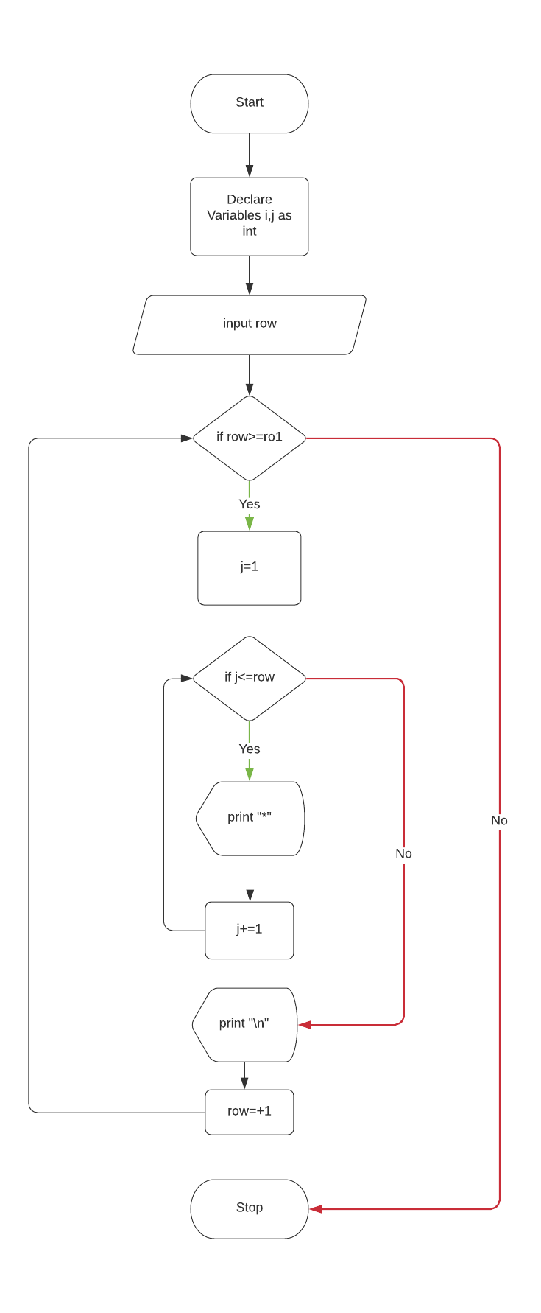

Algorithm :-

Step – 1 Start

Step – 2 – Declare and initialize required variables for controlling loop, inputting numbers of rows and printing \*.

Step – 3 Enter the numbers of rows to be printed

Step – 4 Print the \* and go to step-5

Step – 5 print inverted half pyramid of \*

Step – 6 Stop

\* \* \* \* \*

\* \* \* \*

\* \* \*

\* \*

\*

4. Inverted half pyramid of numbers :-

1 2 3 4 5 6

1 2 3 4 5

1 2 3

1. 2

1

Algorithm :-

Step-1 Start

Step – 2 Declare and initialize required variables for controlling loop, inputting numbers of rows and printing numbers.

Step – 3 Enter the numbers of rows to be printed

Step – 4 Print the numbers and go to step-5

Step – 5 print inverted half pyramid of numbers

Step – 6 Stop

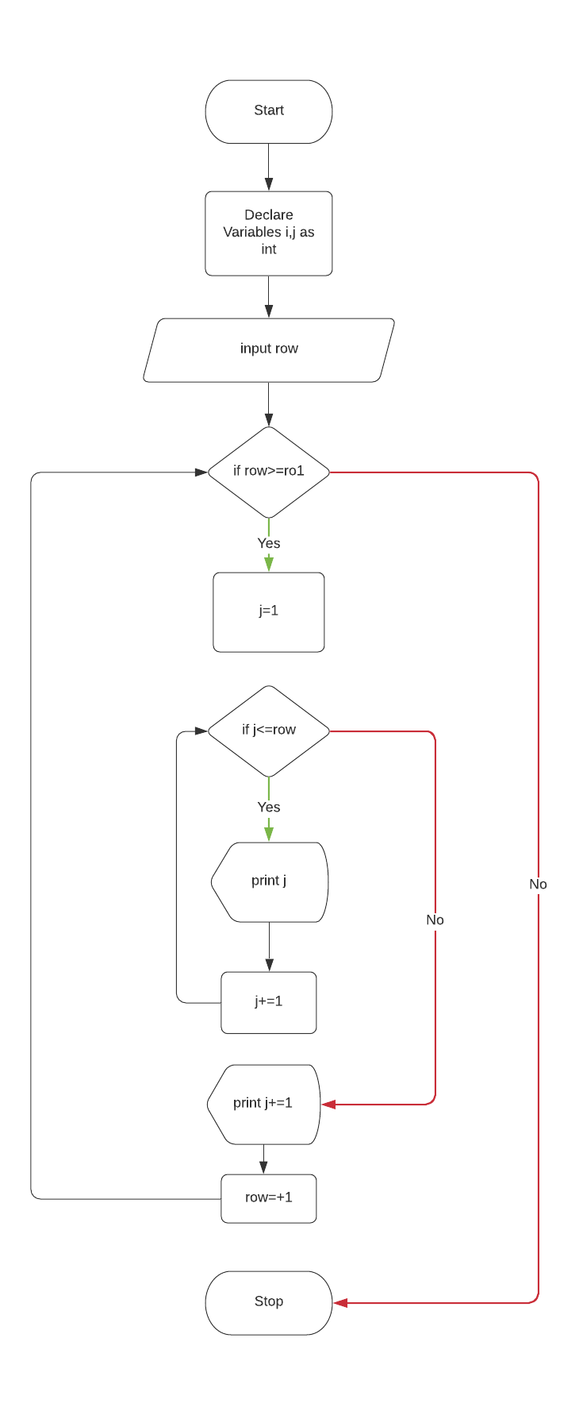

5. Half Pyramid of Alphabets :-

A

B B

C C C

D D D D

E E E E E

Algorithm :-

Step-1 Start

Step – 2 Declare and initialize required variables for controlling loop, inputting numbers of rows and printing Alphabets.

Step – 3 Enter the numbers of rows to be printed

Step – 4 Print the Alphabets and go to step-5

Step – 5 print half pyramid of Alphabets

Step – 6 Stop

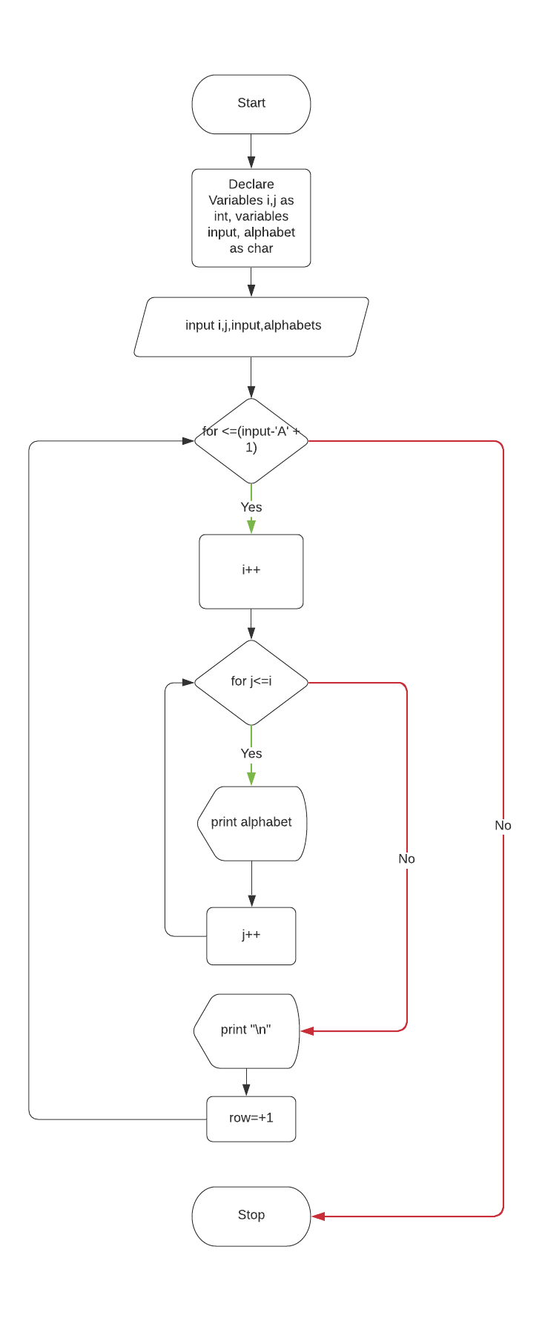

6. Half pyramid of numbers :-

1

1 2

1 2 3

1 2 3 4

1 2 3 4 5

Algorithm :-

Step-1 Start

Step – 2 Declare and initialize required variables for controlling loop, inputting numbers of rows and printing numbers.

Step – 3 Enter the numbers of rows to be printed

Step – 4 Print the numbers and go to step-5

Step – 5 print half pyramid of numbers

Step – 6 Stop

